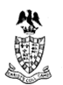 From some old headed documents I was given

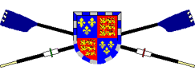 From the boat club website

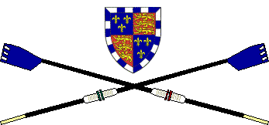 From last year’s JCR report

 From the Christ’s College website